Air Traffic Control (M6932)
Assignment 1 (100 marks = 10% Weightage)
Date Release 28th Feb 2020
Date Due 8th March 2020

Student Name : TAN LAI CHIAN ALAN

Student ID : G19002299C

Q1: Use the attached IFR Enroute Low Altitude Chart for region around Chicago O’Hare Airport to answer following questions:
- A VOR/DME is located at Chicago O’Hare
  - What is the ICAO identifier for the VOR/DME ORD
  - What frequency and channel does the pilot tune to use the VOR/DME 113.9 Mhz, Channel 86
- The 090 degree radial outbound from the Chicago O’Hare VOR along with the 21 nm range from the Chicago O’Hare DME defines an intersection.
  - What is the name of that intersection WILLA
- The 089 degree radial outbound from the Chicago O’Hare VOR along with the 14 nm range from the Chicago O’Hare DME defines an intersection
  - What is the name of that intersection LAIRD
- The FARMM intersection is north-west of the Chicago O’Hare VOR/DME on the 314 degree radial outbound of the VOR and 29 nm range from DME.
  - The FARMM intersection is located on which airway running approx. east-west? V24
- For Airway V116 on 090 degree radial outbound from the Chicago O’Hare VOR/DME
  - What is the Minimum Enroute Altitude 4000
  - What is the Minimum Obstruction Altitude 1800

(Total 16 Marks, 2 Marks each)

Q2: Match the OBI readings with the eight (8) aircraft positions shown on VOR radial/course: You may indicate using an arrow connecting aircraft position to their respective OBI displays.

16 Marks (2 Mark each)
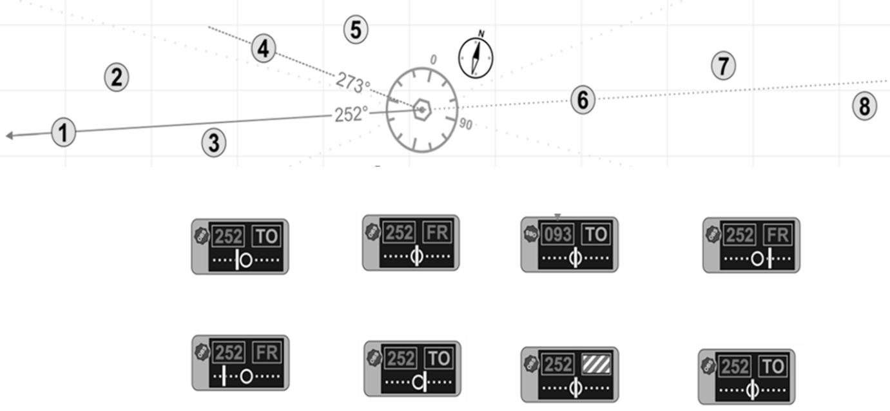

Q3: Download the Investigation Report by German Federal Bureau of Aircraft Accidents
Investigation into Ueberlingen/Lake of Constance/Germany Accident involving Boeing
B757-200 and Tupolev TU154M which lead to loss of 71 lives
http://cfapp.icao.int/fsix/sr/reports/02001351_final_report_01.pdf
[14 Marks, 7 marks each]

- Draw the labelled incident diagram of the accident showing the time stamped sequence of events. Follow the example of TCAS incidents shown in the Slide 95 of Lecture Air Traffic Surveillance Systems. Please include time stamp with each event box.

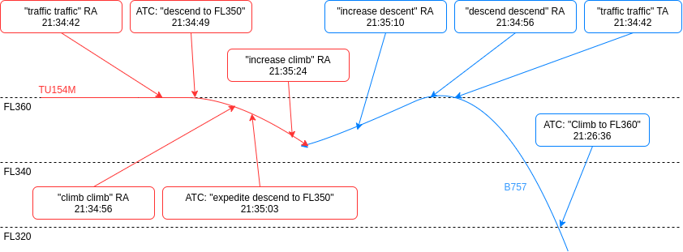
Boeing 757-200
21:21:50 – PIC: “Approaching ABESI”, FL260
21:21:56 – ATC: “Squawk 7524”, “Climb to FL320 and approach TANGO VOR”
21:22:36 – PIC: “Request climb to FL360”
21:26:36 – ATC: “Climb to FL360”
21:29:50 – (B757-200 reached FL360)
21:34:30 – Copilot handed over control of airplane to PIC to go lavatory
21:34:31 – PIC confirmed taken over
21:34:42 – Traffic Advisory (TA): “traffic, traffic”,
21:34:56 – Resolution Advisory (RA): “descend, descend”
21:34:58 – Autopilot (AP) switched off, PIL making descend
21:35:05 – Copilot: “Traffic right here”, PIC: “yes”
21:35:10 – Resolution Advisory (RA): “increase descent, increase descent”
21:35:14 – Master Caution Aural Warning is heard for 2 seconds
21:35:18 – Autothrottle switched off by crew
21:35:19 – B757: “TCAS descent”
21:35:20 – Rate of descent at 2600 ft/min
21:35:26 – Copilot to PIL: “descent”
21:35:30 – Copiliot to PIL: “descent hard”
21:35:32 – Collision happened at FL of 34890 feet.

Tupolev TU154M
21:30:11 – FL360, PNF contacted ACC Zurich
21:30:33 – ATC: “Squawk 7520”
21:33:00 – TCAS: airplane approaching from the left
21:34:42 – Traffic Advisory (TA) “traffic, traffic”
21:34:49 – ATC: “descend to FL350”
21:34:56 – Resolution Advisory (RA) “climb, climb”
21:35:03 – ATC: “… descend level 350, expedite descend”
21:35:24 – Resolution Advisory (RA) “increase climb”
21:35:32 – Collision happened at FL of 34890 feet.

- Explain the following contributing factors in the Ueberlingen air crash

- Single Person Operation Procedure
  - The night shift for controllers was not a Single Man Operation Procedure (SMOP)
- Ground Radar downgrade
  - A modification of the sectorisation of the upper airspace had been planned. For this purpose, a modification of the flight plan processing system was necessary, and several radar systems were affected.
  - As a result, controllers had to work in the fallback mode. This means that the visual STCA was not available and there was no automatic correlation between flight plan data and the target symbol.
- Monitoring of two frequencies by one ATC
  - Controller of ACC Zurich had also to handle a delayed approach of an Airbus 320 to Friedrichshafen on frequency 119.920 MHz.
  - The work station for this approach was right next to the work station from which he had to guide the B757-200 and the TU154M and could be reached by rolling his work chair.
  - Message of B757-200 crew at 21:35:19 hrs that they had inititated a descent due to TCAS was not heard by the controller.
  - The imminent separation infringement was not noticed by ATC in time. The instruction for the TU154M to descend was given at a time when the prescribed separation to the B757-200 could not be ensured anymore.
- Ground to Ground Communication
  - ATS ground-ground telecommunication system to be switched off in order to perform sectorisation changes.
  - Controller was unable to establish connection with Friedrichshafen, due to technical defect that occurred in the Bypass System, an analogue system which uses the public telephone network, which occupied his attention for an extended period before the collision between B757-200 and TU154M happened.
- TCAS
  - Conflicting ATC-RA instruction. Pilots did not follow RA to climb but followed ATC instruction to descend instead.

Q4: For the given STAR chart below, answer the following Questions:
[17 Marks]

a. Entry point and coordinates of the STAR route
WAREN, S38°01.00’ E145°18.42’
b. Distance between
I. MONTY & SANDR - 11NM
II. LAGUG & NEFER - 3NM
c. Bearing between
I. UPKID & GOOLA - 271
d. Altitude restrictions at SANDR – 8000FT
e. Speed restrictions at UPKID - 230KT
f. Fill in the blanks:
RWY 16 UNIFORM:
- From WAREN track 319° to MICHM
- Track 320° to MONTY
- Track 323° to SANDR
Cross SANDR AT or BLW 8000 FT
- Track 323 to LAGUG
IAS AT 230 KT from LAGUG
- Track 323° to NEFER
Cross NEFER AT or BLW 6000 FT
- Turn LEFT, track 249° to BOL NDB
MAX IAS 185 KT from BOL NDB
- Track via RNAV-M (RNP) RWY 16
Q5: For the Williamsport Regional Airport show in the map below, please answer the following questions : [18 Marks]
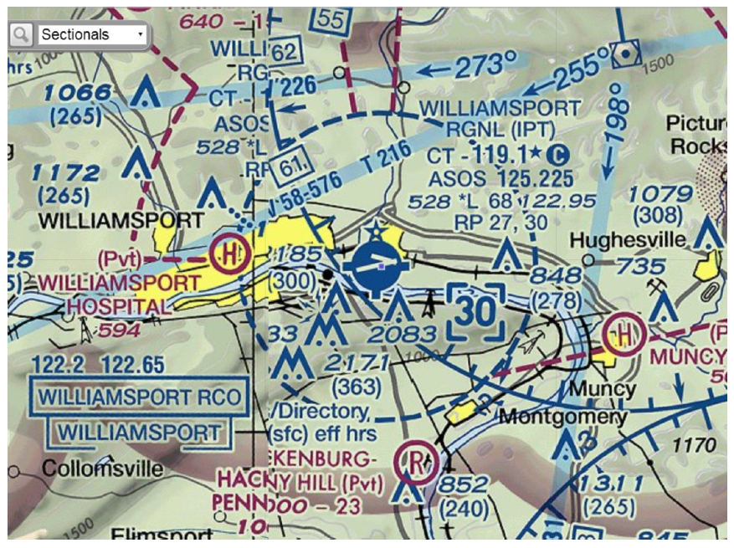

- Does it have rotating beacon from Sunset to Sunrise? Yes, depicted by the blue star with a white solid circle symbol
- Is fuel available at this airport? Yes, tick marks around the basic airport symbol indicates that fuel is available
- Does it have Flight Services facility? Yes, heavy line box indicates FSS.
- What is the control tower primary frequency? 119.1 MHz
- Does this airport operate full time or part time? Part-time, denoted by the blue star beside the CT primary frequency.
- Is runway lighting operational from sunset to sunrise? No, *L indicated that lighting limitations exist; refer to Supplement.
- Is it a public use airport or private use airport? Public use airport
- Which Runways at this airport have right traffic pattern? Runway 27 and Runway 30
- What is the length of longest runway at this airport in hundreds of feet? 68 Runway length is the length of the longest active runway, including displaced thresholds and excluding overruns. Runway length is shown to the nearest 100’, using 70 as the rounding point; a runway 8070’ in length is charted as 81, while a runway 8069’ in length is charted as 80.

Q6: [19 Marks]
a) A Southwest Airline Airbus A320 departs Washington Dulles (IAD) airport for Los Angeles (LAX). The pilot requests an initial altitude to be flown. Which of the two altitudes below is allowed for this flight? [4 Marks]
i. 34,000 feet
ii. 35,000 feet
Explain the reason for your selection.
The direction from IAD to LAX has a magnetic track of 284 which is between 180 and 359. Given that it is an IFR flight, FL 340 (34000 feet) is a valid IFR cruising level (even thousand feet) while FL 350 (35000 feet) is not (odd thousand feet).
https://www.faa.gov/air_traffic/separation_standards/rvsm/documents/ICAO%20ANNEX%202_APP3_dwnld_10152015.pdf
b) An aircraft traffic controller separates traffic in the Singapore Airspace using SSR only, without its associated primary radar. If there are two aircraft located 165 nm and two aircrafts located 45 nm from the radar antenna, what is the minimum horizontal separation used in the two cases? (Hint: Consult AIP Singapore) [4 Marks]
For the two aircraft located 165 NM from the radar antenna, the minimum horizontal separation is 15 NM.
For the two aircraft located 45 NM from the radar antenna, the minimum horizontal separation is 10 NM.
The minimum horizontal radar separation are: a) 7 NM beyond 150 NM from Singapore Changi Airport and b) 5 NM up to 150 NM from Singapore Changi Airport. Whenever SSR is used without its associated primary radar the separation minimum in a) and b) are increased to 15 NM and 10 NM respectively.
c) A pilot reports to ATC to be in cruise at flight level 370 over Arizona USA. What is the altitude of this aircraft above sea level? What is the general direction of flight (i.e., North, South, East, and West) ? Explain [4 Marks]
Altitude of aircraft above sea level is 37000 feet when pressure at sea level is 1013.25 hPa or 29.92 in Hg and aircraft altimeter is set to QNH (standard altimeter setting). Otherwise, if pressure at sea level is not 1013.25 hPa, then pilot will need to set to QNH (either locally measured pressure or regionally forecasts) to get the altitude above sea level. QNH is given by ATC with the first descend clearance to an altitude below the transition level, however given that aircraft is not landing by only cruising over Arizona, QNH might not be given.
Odd number IFR FL 370 therefore general direction is either North, East, or South.
d) When operating in the Singapore Flight Information Region, no aircraft should file a flight plan to cruise at FL115, FL120 and FL125. What is the reason for this restriction? Explain. [4 Marks] (Hint: Consult AIP Singapore)
Because the Singapore FIR’s transition layer is from 11000 feet to 13000 feet with transition altitude at 11000 feet and transition level at FL130 (13000 feet). Cruising within the transition layer is not permitted unless specifically cleared by the ACC of that FIR.
A common transition altitude of 11000 feet (3350 metres) has been established in the Singapore FIR. This will ensure uniformity in the transition altitudes for aerodromes within the territories of Brunei, Malaysia and Singapore.
The maximum variation in QNH values in the Singapore FIR does not exceed 10hPa either side of the standard setting 1013.2hPa, representing a change of about 300 feet on the altimeter from QNH to 1013.2hPa. To simplify ATC procedures, a transition level of FL130 has been established, thus providing a transition layer of 2000 feet and ensuring at all times the 1000 feet vertical separation between aircraft. Therefore, no aircraft should cruise at flight level 115, 120, and 125 when operating in the Singapore FIR because these flight levels fall within the transition layer.
e) Name the six airways that crosses through Singapore Airspace Sector 2E.
[3 Marks] (Hint: Consult AIP Singapore)
1) B469, 2) L642, 3) M771, 4) N892, 5) N884, 6) N891
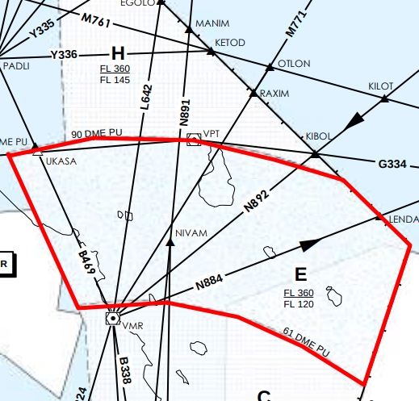
AREA E (61 DME PU - 90 DME PU) - FL120 to FL360 of SECTOR 2
